MED D - Blue MedicareRx (NEJE) 2025 AEP Readiness

Annual Notice of Change (ANOC) Mailing
Electronic Evidence of Coverage, and Formulary
Multi-Language Interpreter Service
Pharmacy Networks
Mail Order Pharmacies
Premium Billing Payment Information
Medicare Part D Benefit Parameters for Defined Standard Benefit
Inflation Reduction Act
Cost Sharing in the Coverage Gap (Donut Hole)
Low Income Subsidy Rider
Blue MedicareRx (NEJE) Value Plus Plan Design
Blue MedicareRx (NEJE) Value Plus Formulary Changes
Blue MedicareRx (NEJE) Premier Plan Design
Blue MedicareRx (NEJE) Premier Formulary Changes
Tiering Exceptions/Coverage Determinations
Dissatisfaction Identified
Log Activity
Related Documents

Description: In an effort to minimize the amount of time the MED D Customer Care Representative (CCR) spends searching for readiness documents, this job aid holds links to the documents most frequently used for the 2025 Annual Enrollment Period (AEP).

Annual Notice of Change (ANOC) Mailing
- Beneficiaries will receive the ANOC package no later than September 30, 2024.
- Components are mailed in a 6 x 9 envelope and mailings will occur:
  - Individual Beneficiaries: September 21, 2024
  - Group Beneficiaries: November 2nd through November 4, 2024.
Example:

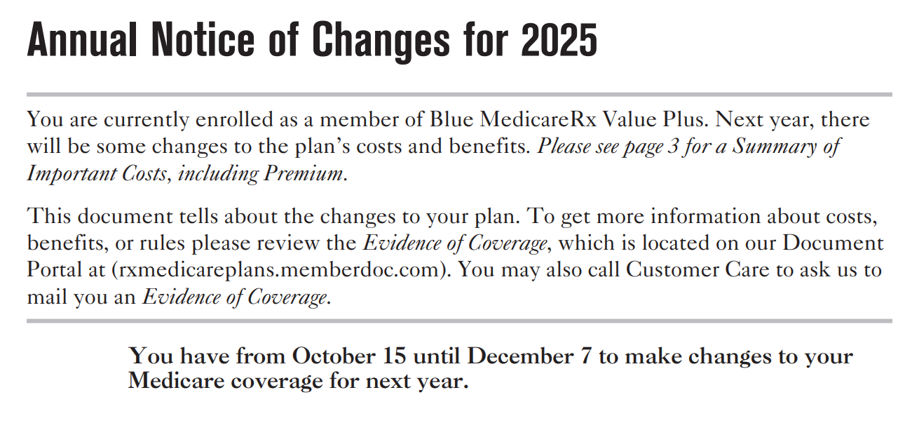

Agents and call center representatives are not permitted to discuss 2025 plan information prior to October 1st UNLESS a current Blue MedicareRx beneficiary asks questions AFTER receiving the ANOC mailing.
  - If beneficiaries want to stay with their current plans, then they don’t need to do anything.
  - If beneficiaries prefer to change plans, then they can enroll in a different plan between October 15th and December 7th.
- Coverage will begin on January 1st.
- Beneficiaries expect agents and call center representatives to know the information contained in the ANOC package.

Example:

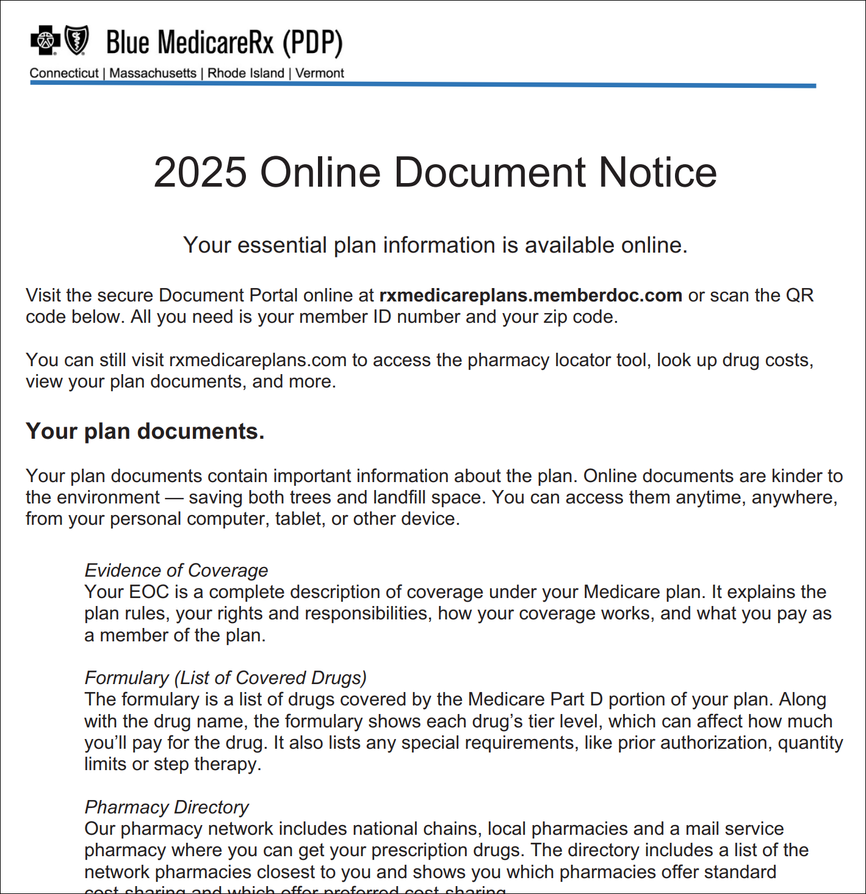

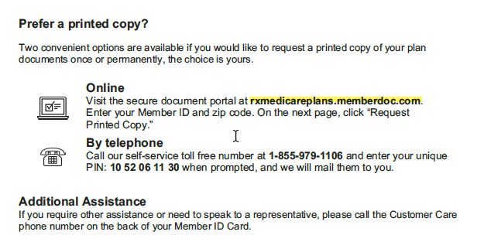

Online Document Notice

- The ANOC includes any changes in coverage, costs, or service area that will be effective in January and notice to receive hard copies of Evidence of Coverage, Formulary, and Pharmacy Directory.
- Beneficiaries should:
  - Check the changes to the plan benefits and costs
  - Check the website for changes to the formulary
  - Check the website for network pharmacies
  - Think about their overall health care costs
  - Think about whether they are happy with their current plan

Top of the Document

Electronic Evidence of Coverage, and Formulary
Refer to Compass MED D - Digital Evidence of Coverage, Formulary and Pharmacy Directory when beneficiary requests a hard copy of Evidence of Coverage, Formulary or Pharmacy Directory.

Top of the Document

Multi-Language Interpreter Service
We have free interpreter services to answer any questions you may have about your health or drug plan. Someone who speaks [language] can help you. This is a free service.

Languages include:
Spanish, Chinese, Tagalog, French, Vietnamese, German, Korean, Russian, Arabic, Italian, Portuguese, French Creole, Polish, Hindi, and Japanese

Refer to MED D Language Assistance - Language Line Services.

Top of the Document

Pharmacy Networks
Blue MedicareRx (NEJE) contracts with a nationwide network of more than 66,000 pharmacies (more than 23,000 preferred pharmacies) to provide convenient access to medications for their plan beneficiaries.
- CVS Caremark Mail Order Pharmacy part of the network.
- Blue MedicareRx (NEJE) network pharmacies are held to high standards for service quality and clinical excellence and are monitored for their effectiveness.
- Blue MedicareRx (NEJE) network pharmacies provide quality service and clinical support including:
  - Face-to-face or telephonic clinical support to manage plan beneficiary medications and address questions or concerns about drug side effects or missed doses.
  - Assist with questions that the beneficiary can ask their doctor on possible gaps in medication therapies that may help to prevent or lower chances of having some problems caused by diabetes such as heart attack and/or stroke.
  - Opportunity for beneficiaries to discuss savings opportunities to address financial barriers that may keep beneficiaries from taking their medications.
  - Provide one-on-one medication review with a pharmacist for beneficiaries having hard time taking a lot of medications and who have many chronic conditions (by invitation only to beneficiaries who meet Medicare’s guidelines).
- Beneficiaries save with 90-day refills at retail or by mail.
  - Beneficiaries can refill ongoing prescriptions for a full 90 days at their local pharmacy, or through the mail, and save more all year long
- Beneficiaries build relationships with pharmacists at one of more than 66,000 participating network pharmacies.
  - Conversations are typically brief and easily fit into a beneficiary’s pharmacy visit or short telephonic conversation.

Blue MedicareRx (NEJE) Pharmacy Directory (available online or request by beneficiary) contains over 25 of the nearest pharmacies, based on beneficiary’s address.

Top of the Document

Mail Order Pharmacies
The only mail order pharmacy in network is CVS Caremark.
- Due to CMS requirements, a plan may charge a differential against retail for up to a 90 day supply based on the difference between higher contract rates at a retail pharmacy compared to mail order.
- To obtain specific plan information:
  - Current enrollees should consult the Evidence of Coverage (EOC)
  - Prospective enrollees should consult the Summary of Benefits (SB)

Top of the Document

Premium Billing Payment Information
- Billed in advance (For example, the January premium is billed in December)
- Premium billing cycles:
  - Premium payments are due on the 1st of each month
- Premiums can be paid via
  - Automatic deduction options – Social Security or Rail Road Board deduction, EFT/ACH, or Credit Card
  - Beneficiaries who have enrolled into an automatic payment option will have their payment deducted between the 8th and 10th
of each month.
    - ACH/ EFT (Electronic Funds Transfer)
    - Recurring credit card deductions
    - Beneficiaries receiving Employer Group/SPAP subsidies for their premium should not utilize premium auto-pay options
    - SSA/RRB Deduction combined with an Employer Group or SPAP subsidy can cause a double payment of the premium because CMS does not account for the client subsidy
  - Invoice monthly and pay by check
    - When paying by check, beneficiaries must write their Member ID on their check
    - Beneficiaries must enclose separate checks if paying for more than one beneficiary’s premium
    - Beneficiaries paying via bank online option needs to allow time for bank to mail physical check to plan and post to account by the first of the month.

Top of the Document

Medicare Part D Benefit Parameters for Defined Standard Benefit
Each year CMS changes the standard benefits for Part D.

The illustration below displays the costs comparison between years for the different stages of coverage for the standard benefit.

2025 CMS Standard Medicare Part D Standard

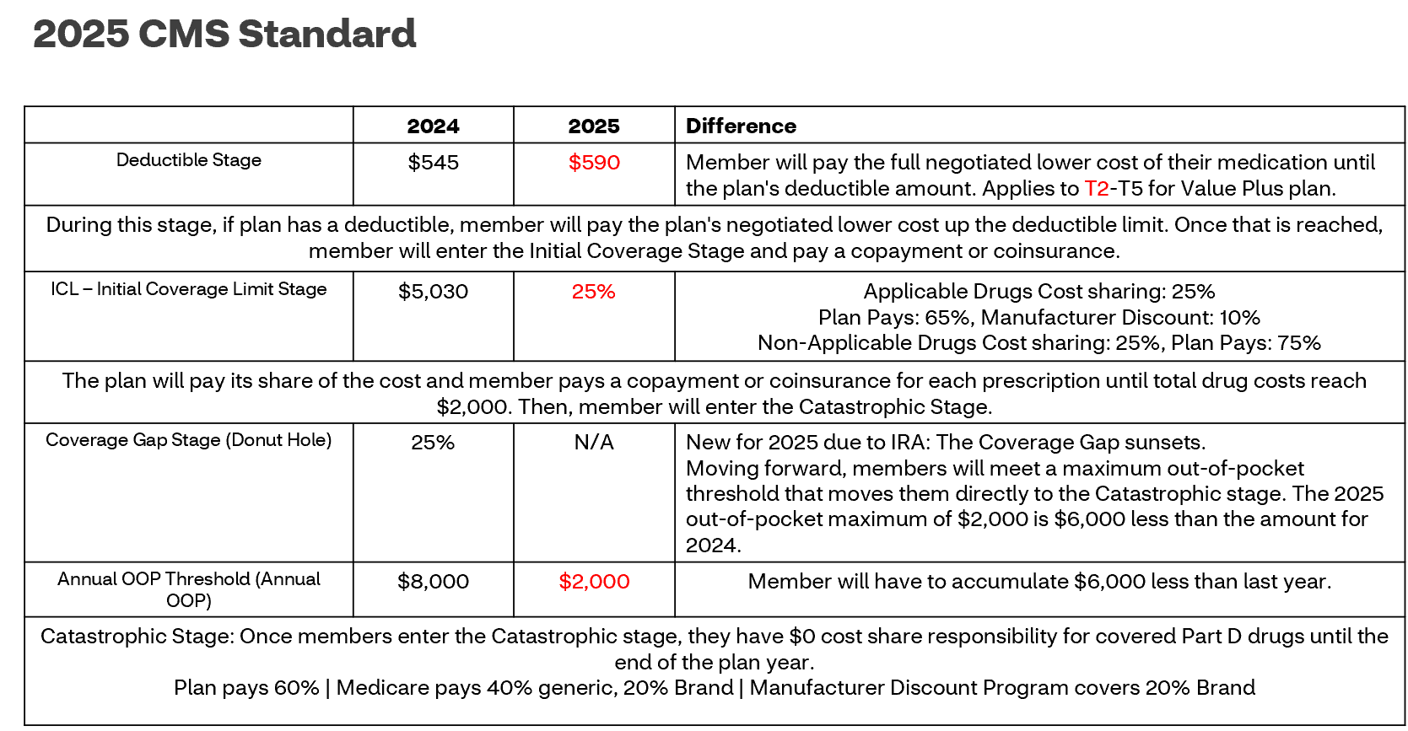

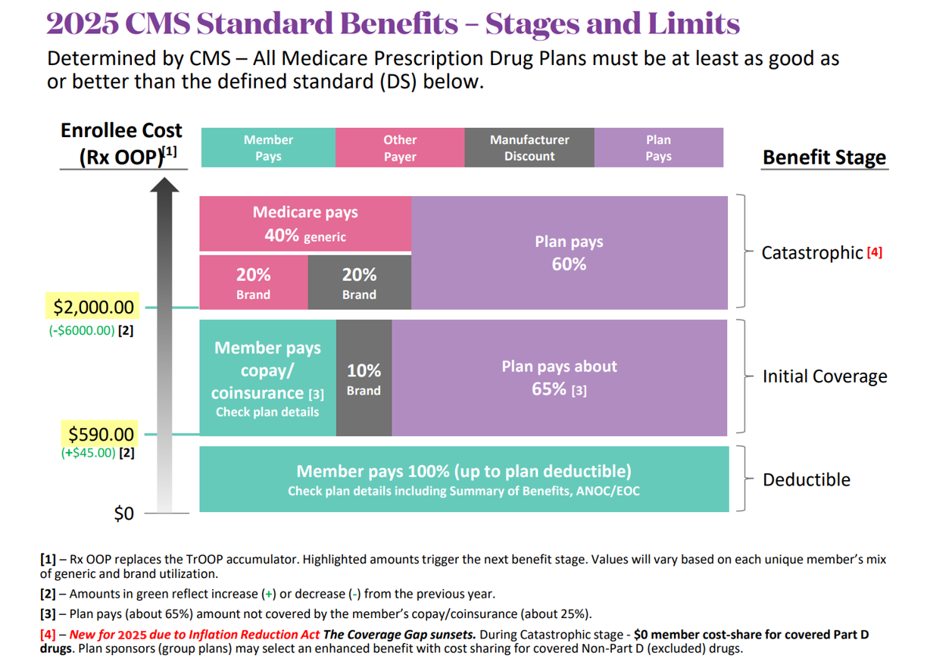

2025 CMS Standard Medicare Part D Standard
Year | Deductible | ICL | Coverage Gap/TrOOP | Catastrophic
2025 | $590.00 | 25% | No Coverage Gap Annual Out Of Pocket Max $2,000 | Part D Drugs:  $0 member cost-share  Covered Non-Part D Drugs: Varies by Plan
2024 | $545.00 | $5,030 | $8,000 | $0 member cost-share  Covered Non-Part D Drugs: Varies by Plan

Stage Limits for Prior Years
The image below displays a comparison between prior years for each standard benefit stage limit.

 | 2025 | 2024 | 2023 | 2022 | 2021 | 2018 | 2019
Deductible | $590 | $545 | $505 | $480 | $445 | $435 | $415
ICL Limit | 25% | $5,030 | $4,660 | $4,430 | $4,130 | $4,020 | $3,820
AOOP | $2,000 | $8,000 | $7,400 | $7,050 | $6,550 | $6,3500 | $5,100

Top of the Document

Inflation Reduction Act
Refer to Compass MED D - Inflation Reduction Act

Beneficiaries will not receive an additional errata mailing because the ANOC/EOC/Formulary were updated prior to the original mailing.

Top of the Document

Cost Sharing in the Coverage Gap (Donut Hole)
New for 2025 due to IRA: The Coverage Gap sunsets.

Moving forward, beneficiaries will meet a maximum out-of-pocket threshold that moves them directly to the Catastrophic stage. The 2025 out-of-pocket maximum of $2,000 is $6,000 less than the amount for 2024.

Top of the Document

Low Income Subsidy Rider
- Sent to beneficiaries who either qualify for Low Income Subsidy or have a change in their LIS level.
- First paragraph: “Our records show that you qualify for Extra Help paying for your prescription drug coverage. This means that you will get help paying your <monthly premium, yearly deductible, and prescription drug cost-sharing>”
- The LIS Rider includes the deductibles and copays that the beneficiary pays.

Example:

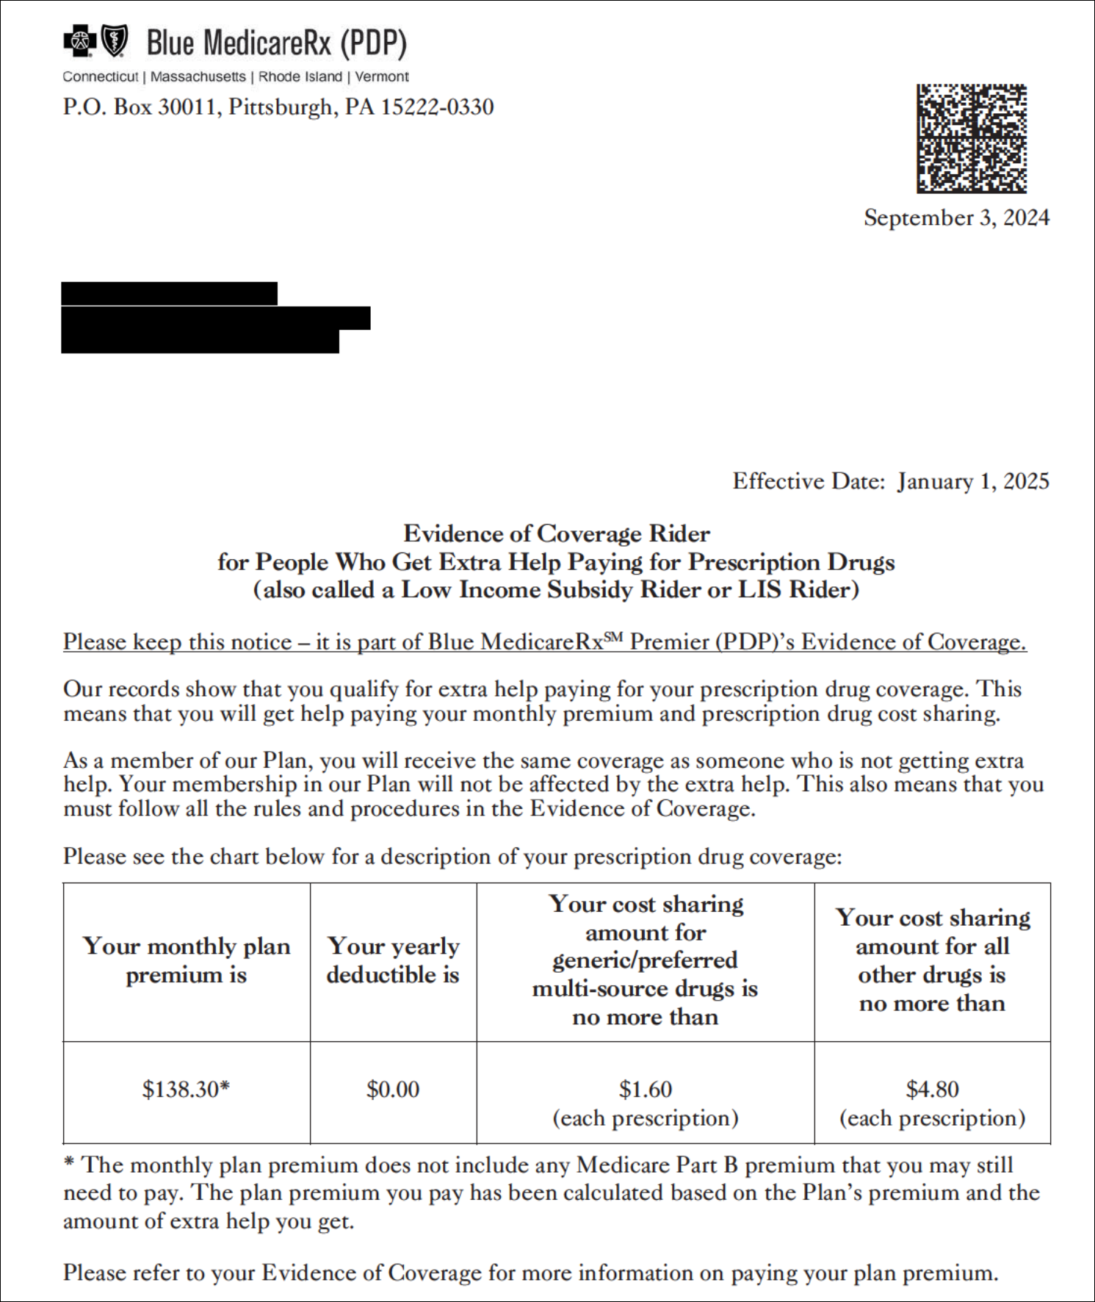

Top of the Document

Blue MedicareRx (NEJE) Value Plus Plan Design

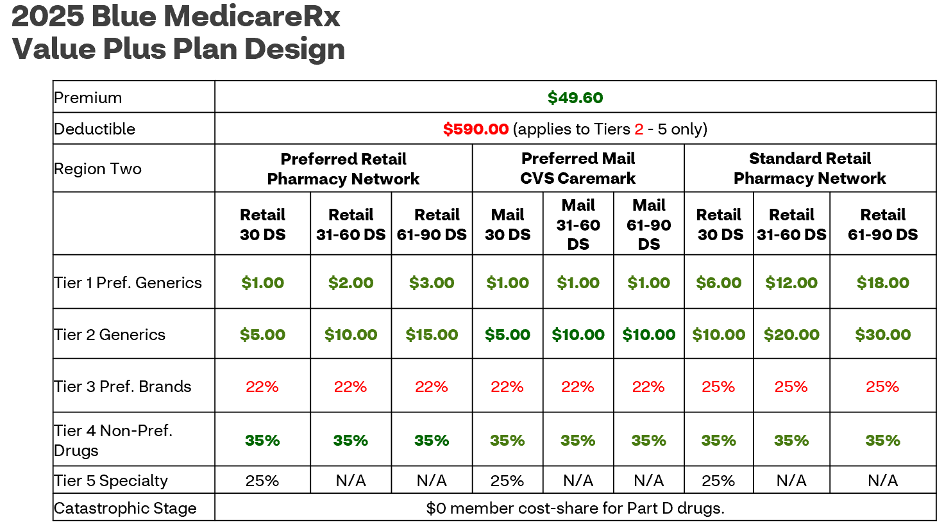

LIS Copay: | LIS 1: $4.90 for Generics; $12.15 for Brands; Catastrophic $0.00  LIS 2: $1.60 for Generics; $4.80 for Brands; Catastrophic $0.00  LIS 3: $0; Catastrophic $0.00
LIS Premium | Premium | Benchmark | LIS 1, 2, 3
LIS Premium | $49.60 | $52.52 | $0
Formulary Changes | - Clinical is available for alternative medication requests.  - Encourage members/potential members to speak to their providers about available formulary alternatives Always fully educate current and potential new members on Deductible when medication is a Tier 2,3, 4, or 5  - 65 drugs removed WITH 35 drugs added  - 17 drugs moving to a Higher Tier

Top of the Document

Blue MedicareRx (NEJE) Value Plus Formulary Changes

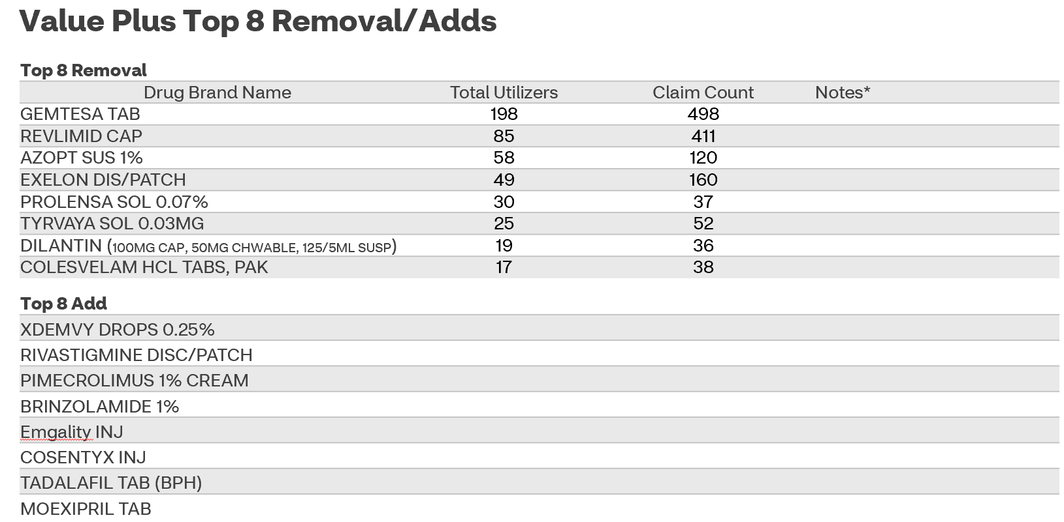

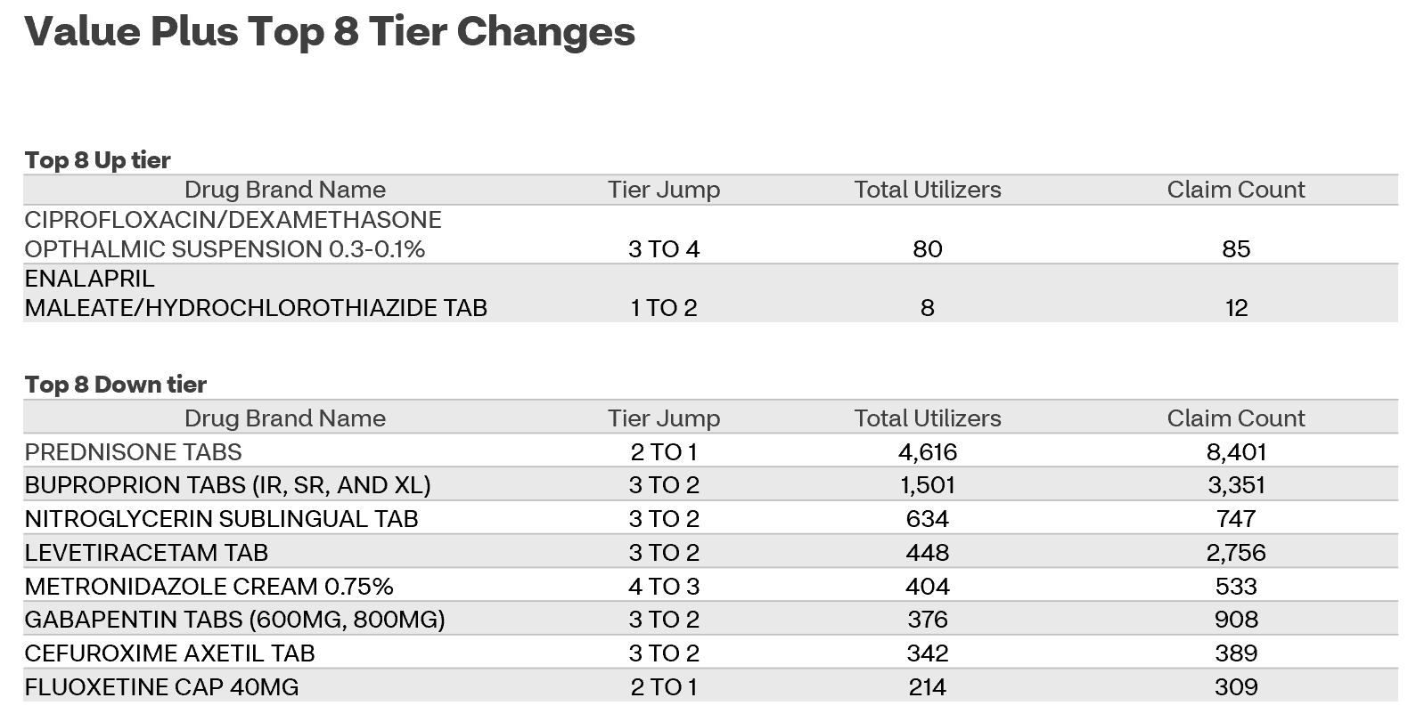

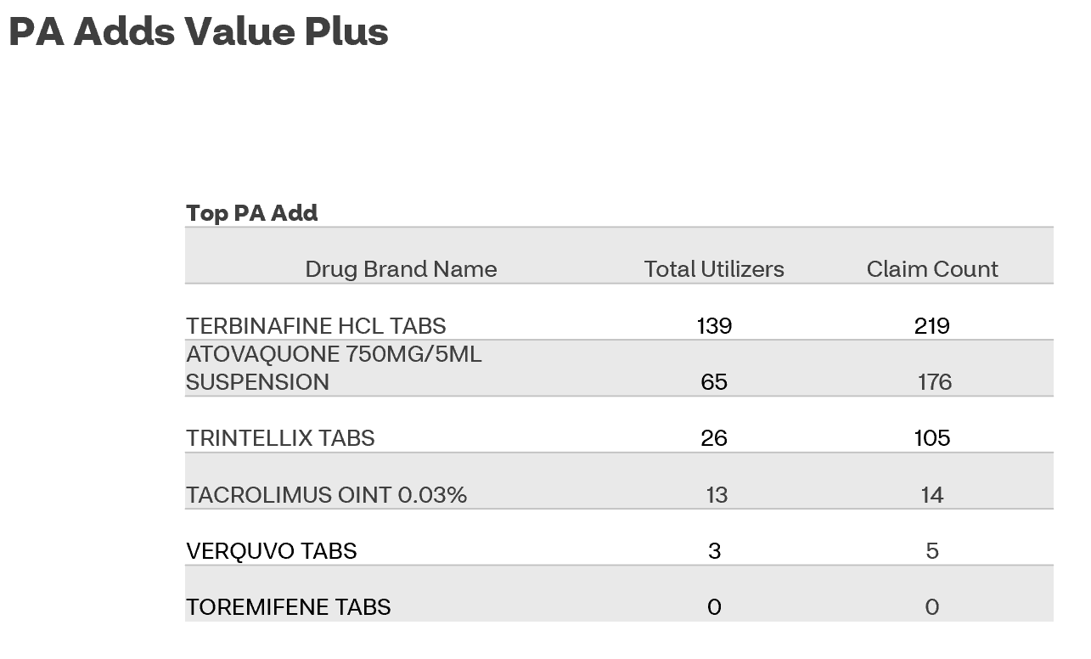

Top of the Document

Blue MedicareRx (NEJE) Premier Plan Design

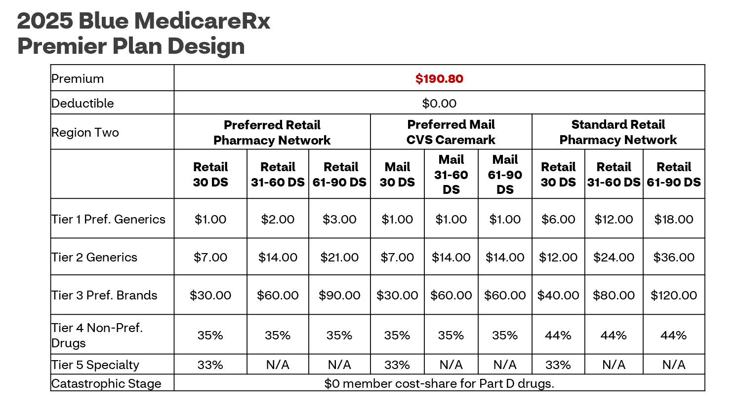

LIS Copay: | LIS 1: $4.90 for Generics; $12.15 for Brands; Catastrophic $0.00  LIS 2: $1.60 for Generics; $4.80 for Brands; Catastrophic $0.00  LIS 3: $0; Catastrophic $0.00
LIS Premium | Premium | Benchmark | LIS 1, 2, 3
LIS Premium | $190.80 | $52.52 | $138.28
Formulary Changes | - Formulary change – many generic medications may move to a higher tier  - Clinical is available for alternative medication requests.  - Encourage members/potential members to speak to their providers about available formulary alternatives  - 73 drugs removed from formulary WITH 31 drugs added  - 42 drugs moving to a Higher Tier

Top of the Document

Blue MedicareRx (NEJE) Premier Formulary Changes

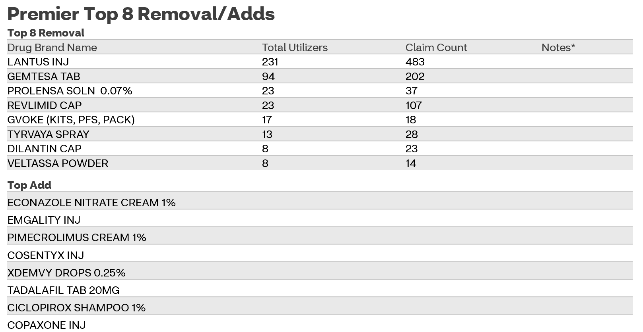

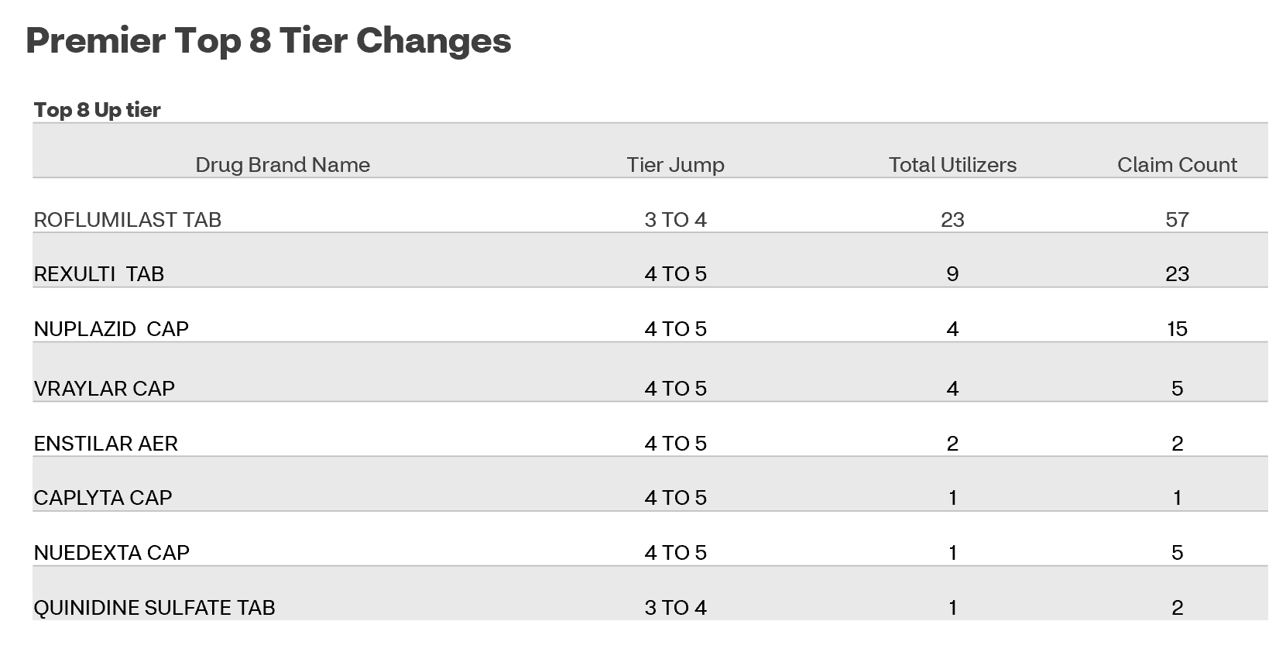

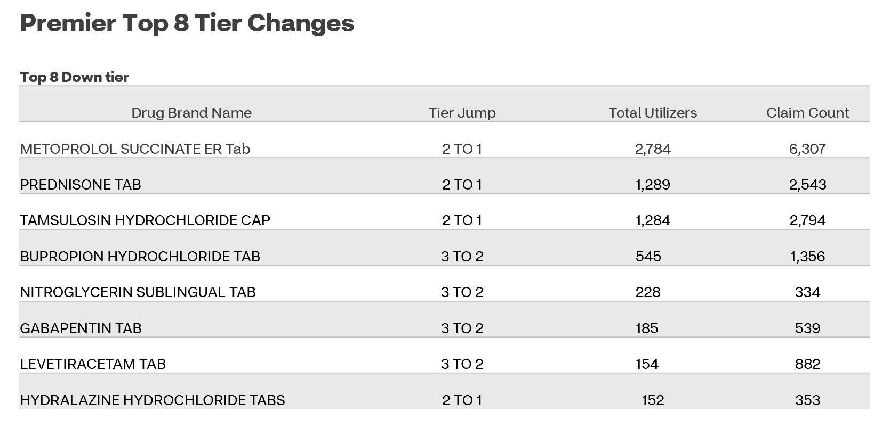

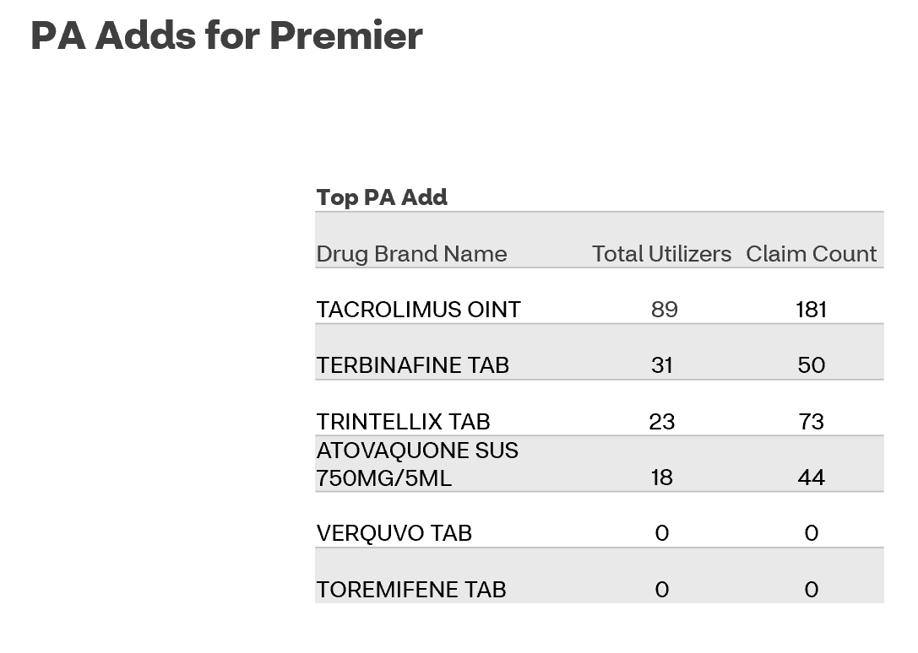

Top of the Document

Tiering Exceptions/Coverage Determinations
2025 Tier Exceptions and Coverage Determinations:
- Beneficiaries / prescribers can start the process November 1st
  - Beneficiary must be in system with a member ID in order to process any Coverage Determination and Appeals case
- This is to allow plenty of time for the request to get approved
- Tier Exceptions for 2025
  - Tier Exceptions can be requested for Tier 2, 3, and 4 medications, if lower tier alternative is available. Educate the beneficiary that it may or may not be approved
  - Requests for Tier 5 medications are not allowed per the plan design
- Refer beneficiaries to their Evidence of Coverage
  - Chapter Seven

Top of the Document

Dissatisfaction Identified
Refer to:
- Compass MED D - How to File a Grievance in Compass
- Compass MED D - CCR - Coverage Determinations and Redeterminations (Appeals)
- MED D - Top Grievance Drivers

Top of the Document

Log Activity
1003 – Plan Design Education

Top of the Document

Related Documents
Parent SOP: CALL-0048: Medicare Part D Customer Care Call Center Requirements-CVS Caremark Part D Services, L.L.C.
Abbreviations/Definitions: Abbreviations / Definitions

Top of the Document
Not To Be Reproduced Or Disclosed to Others Without Prior Written Approval
ELECTRONIC DATA = OFFICIAL VERSION – PAPER COPY = INFORMATIONAL ONLY

